The Territory Proud Management Committee welcomes nominations from our members to join the 2021-2022 Management Committee. The organisation achieves its goals with an involved and active committee filled with a diverse and inclusive group of members.

All positions are vacant, nominations are to be received 7 days before the 2021 AGM.
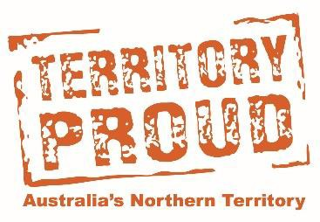
Management Committee Nomination

I ___________________________________ (Nominee) hereby nominate for the 2021-2022 Territory Proud Incorporated Management Committee.
All Nominees to complete:
NOMINEE
Name: | Date:
Member Business: | Signature:
SECONDER
Name: | Date:
Member Business: | Signature:

Elected Executive Positions

I __________________________________ (Nominee) wish to stand for the position below.

Chairperson |  | Secretary
Vice-Chairperson |  | Treasurer

I ______________________________________ (Nominee) accept the above nomination. By signing below, I agree to abide by the Territory Proud Constitution, rules and by-laws as set by the Management Committee.
Signature: ______________________________________ Date: ________________________

* Only eligible members can nominate or second a nomination. The same member business cannot nominate and second the nomination.

